**E-commerce Beauty Product Analysis**

**Objective:**

This analysis aims to enhance operational efficiency and drive product development by uncovering insights into pricing trends, customer preferences, and market demand. Businesses can leverage these insights to optimize inventory, expand product offerings, and maximize profitability.

**Datasets:**

The dataset contains detailed information, including:

Customer attributes: Skin type, hair type, age group, gender.

Product attributes: Popularity rating, primary ingredients, fragrance type.

Market factors: Waterproof, organic, paraben-free, region usage.

Sales insights: Summer essential score, frequency of usage, online availability.

**Key Insights & Findings:**

1. **Pricing Power by Brand**

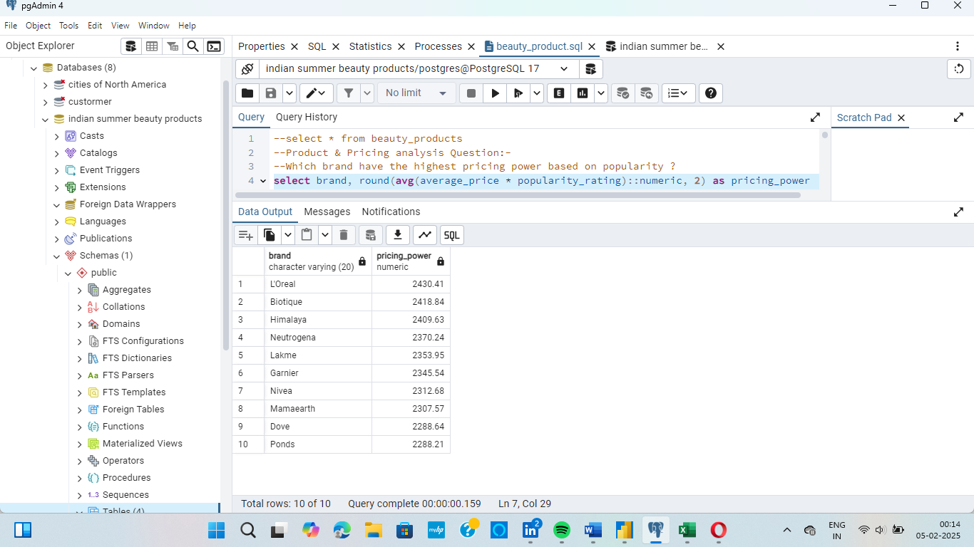Brands with the highest pricing power based on popularity and price:

Insight: L'Oreal leads in pricing power, indicating strong brand influence and customer willingness to pay a premium.

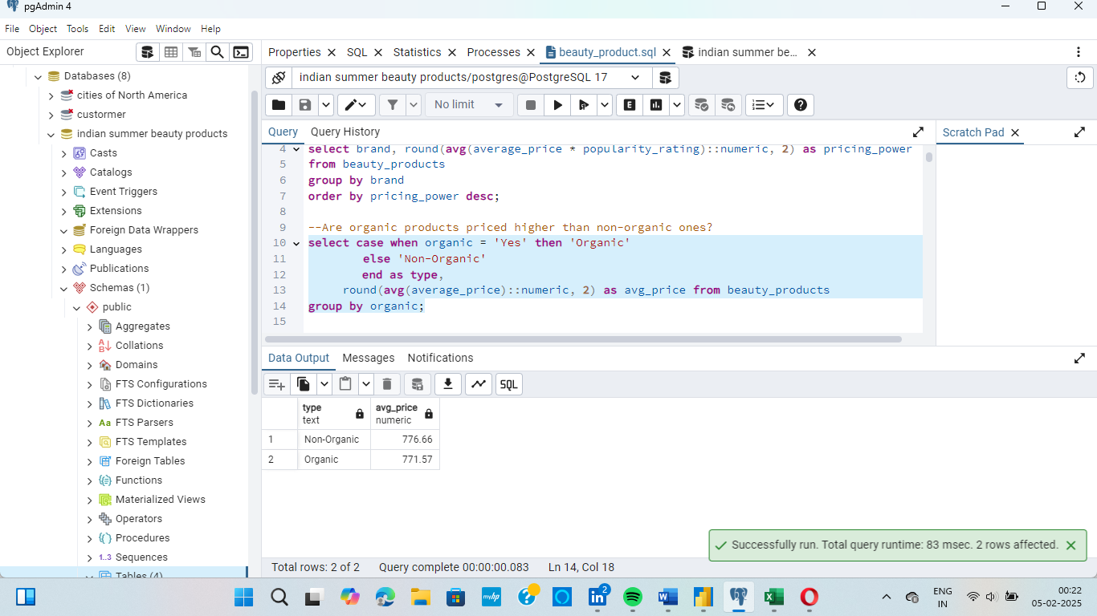**2. Organic vs. Non-Organic Product Pricing (Are organic product more expensive?)**

Insight: Organic products are priced slightly higher than non-organic ones, showing a market preference for organic beauty products, but the difference is minimal.

**3. Overpriced vs. Underpriced Products**

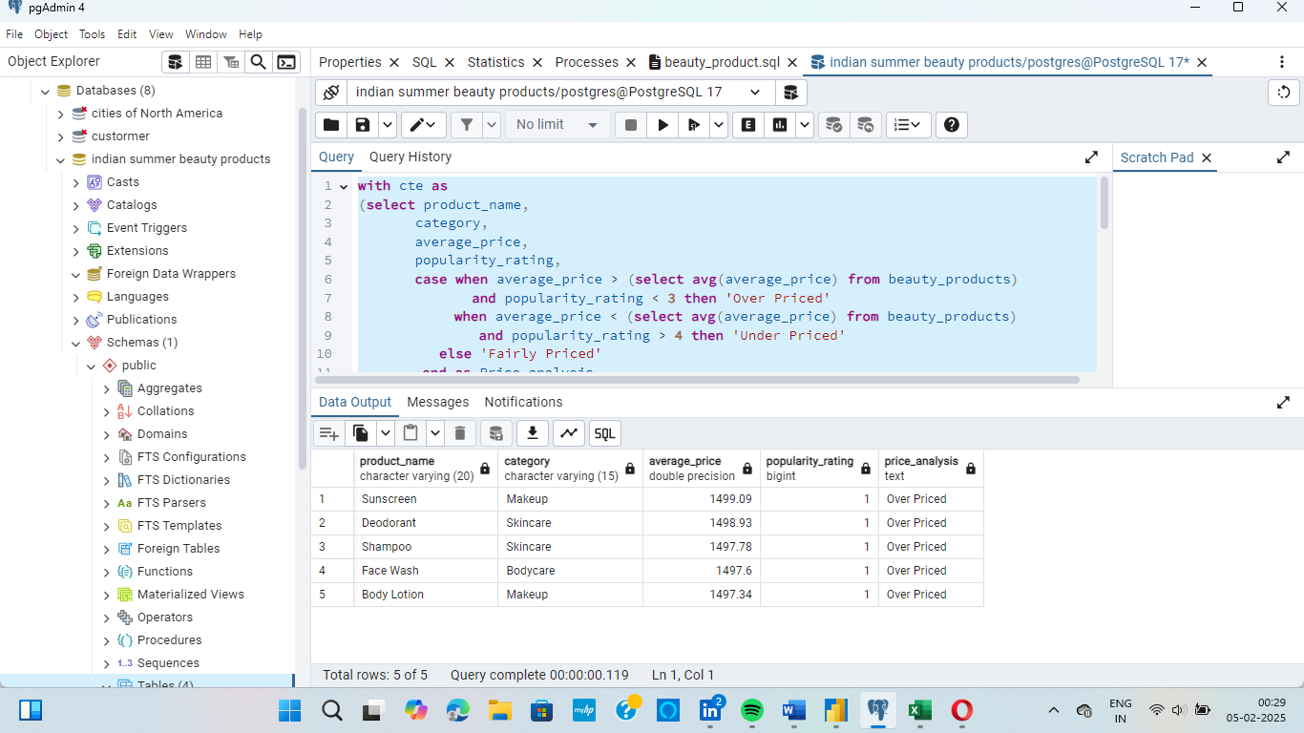 Top 5 Overpriced Products (Low popularity, High average_price)-

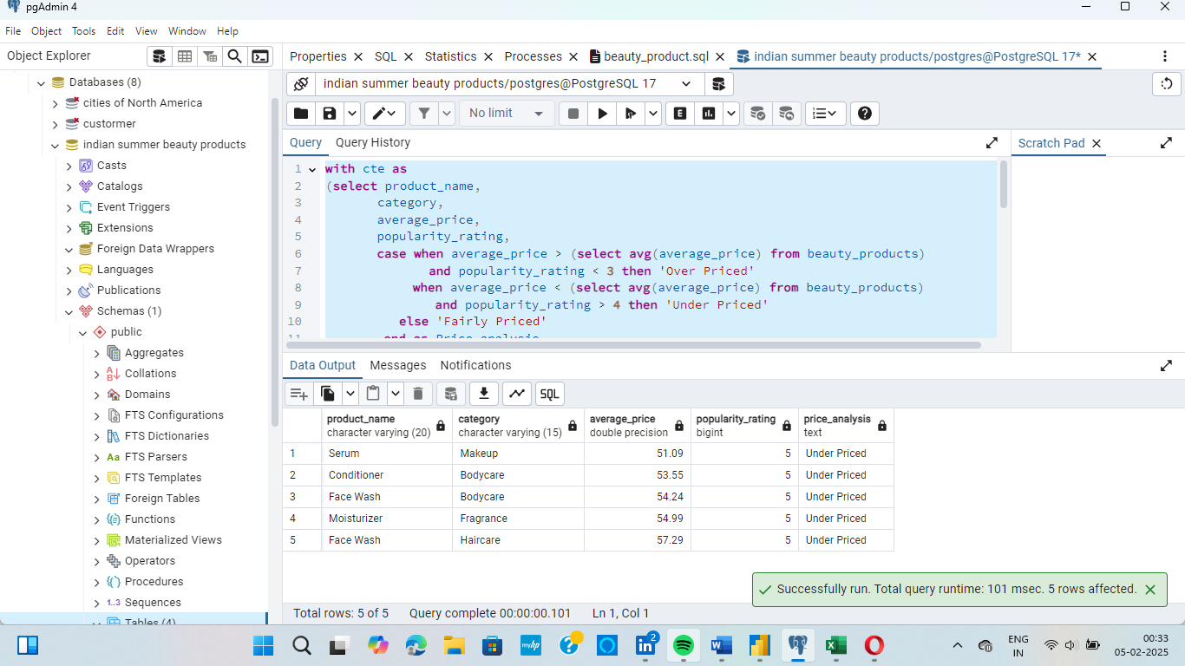 Top 5 Underpriced Products (Low average_price, High popularity)-

Insight: Makeup sunscreen is the most overpriced, while Makeup serum is underpriced.

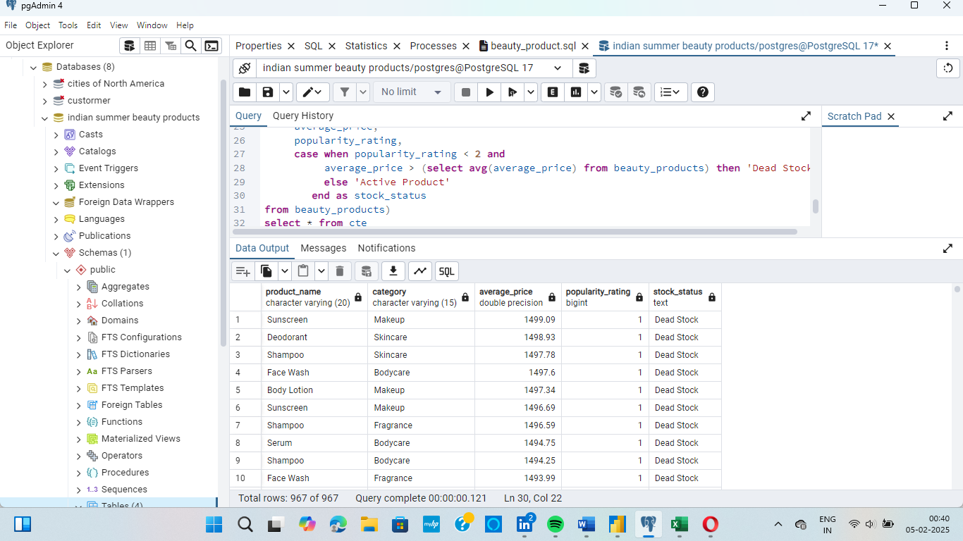**4. Identifying Dead Stock (Unpopular & Overpriced Products)**

Products with high price & low demand (Top 10)

Insight: These products need discount strategies or rebranding to boost sales (Companies should consider discounting these products to clear stock).

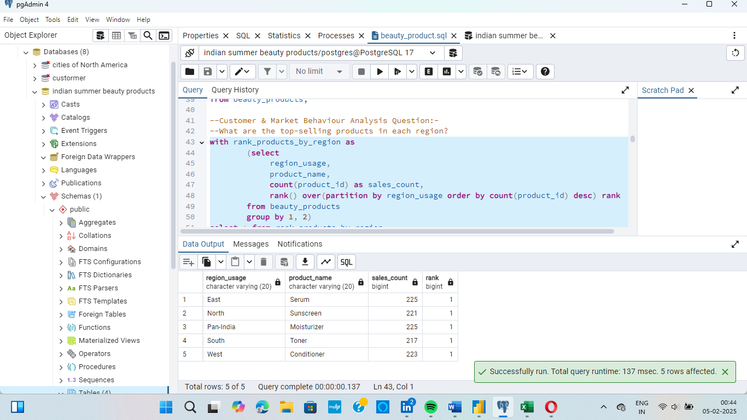**5. Best-Selling Products by Region**

Insight: Serum dominates in the East, while Sunscreen leads in the North. This helps in regional product stocking and marketing strategies.

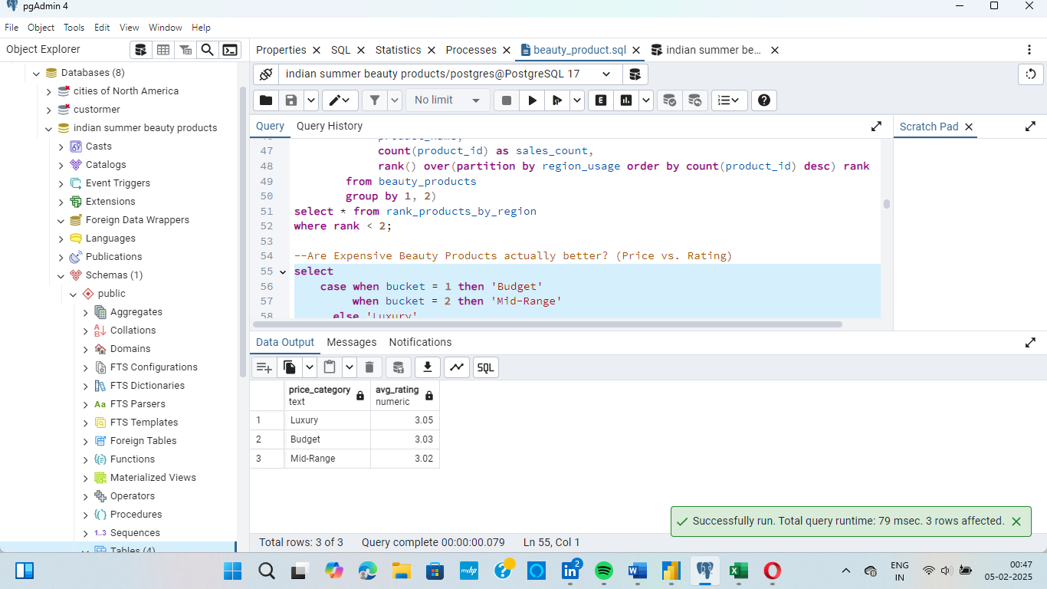**6. Are Expensive Beauty Products Actually Better? (Price vs. Rating)**

Insight: Expensive products have only a slightly higher rating than budget products, indicating that pricing alone does not guarantee quality perception.

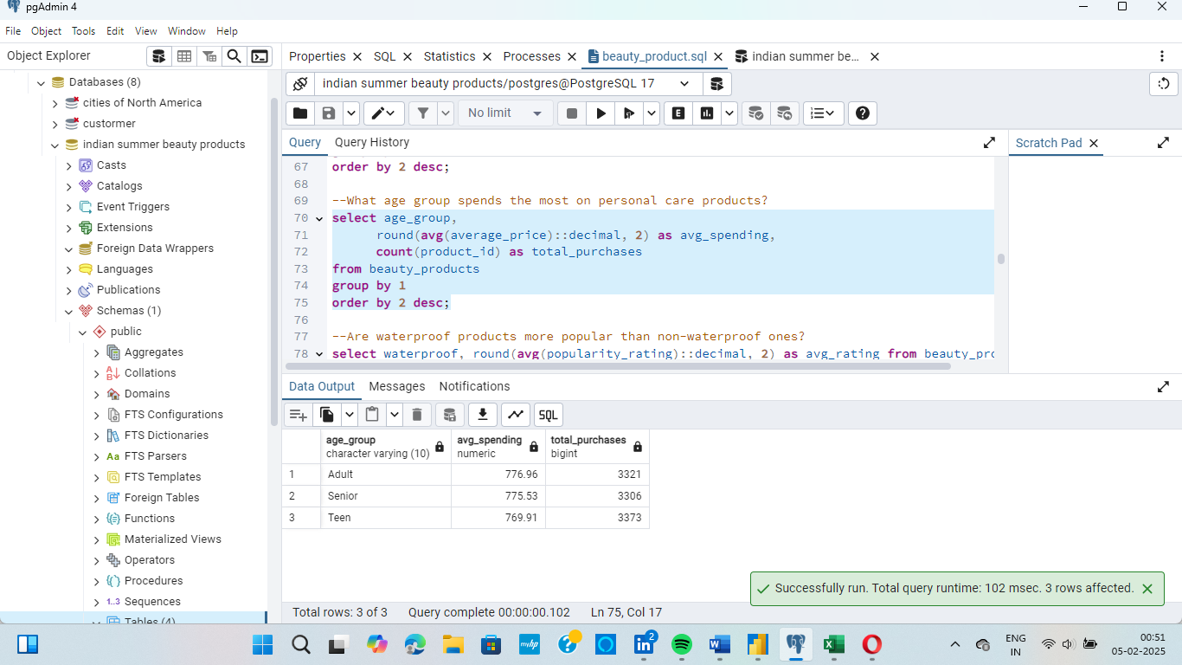**7. Age Group Spending Behavior**

Insight: Teens make the most purchases, but adults spend more per purchase.

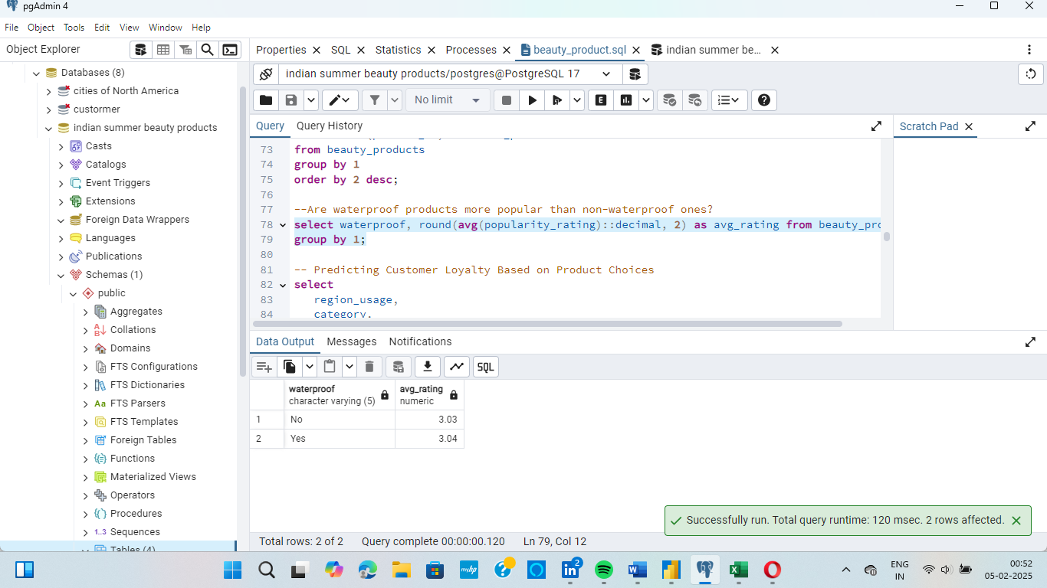**8. Are Waterproof Products More Popular?**

Insight: Waterproof products have slightly higher popularity, indicating a small preference shift.

**9. Predicting Customer Loyalty Based on Product Choice**

Insight: Skincare products have the highest customer loyalty, making them a key focus for repeat sales.

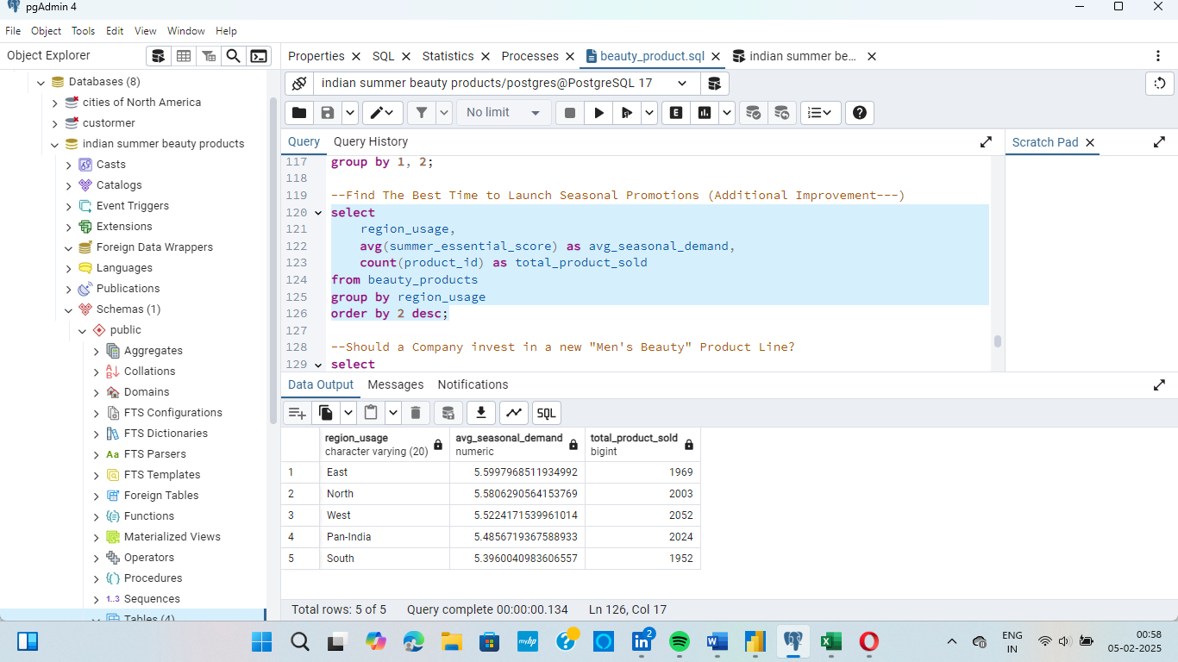**10. Finding the Best Time to Launch Seasonal Promotions**

Insight: East & North regions have the highest seasonal demand. Target promotions accordingly.

**11. Brand Dominance by Category**

Insight: Lakme dominates Makeup & Skincare, while Himalaya leads Haircare, Garnier leads Bodycare and L'Oreal leads Fragrance.

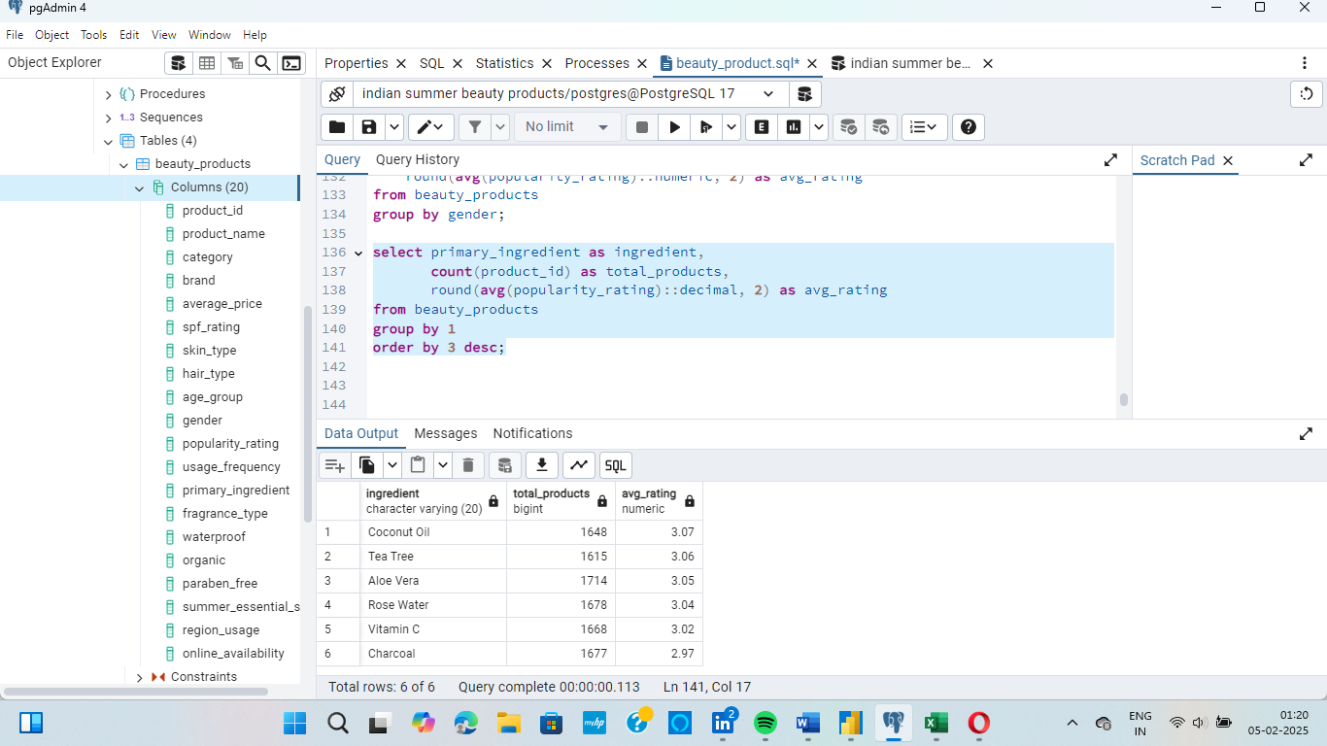**12. Which Beauty Ingredient is Most Preferred?**

Insight: Coconut Oil and Tea Tree based products are the most popular, making it a valuable ingredient for new product development.

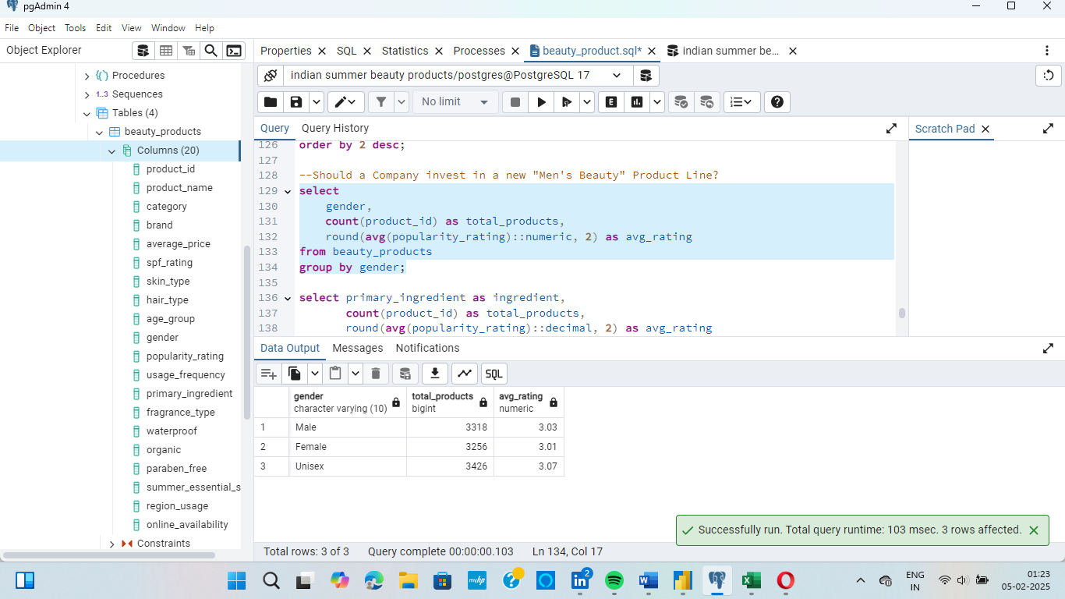**13. Should a Company Invest in a New "Men's Beauty" Product Line?**

Insight: Unisex products have the highest rating (3.07), and Male-focused products have nearly equal demand as Female. Investing in a men’s beauty line could be a good strategic move.

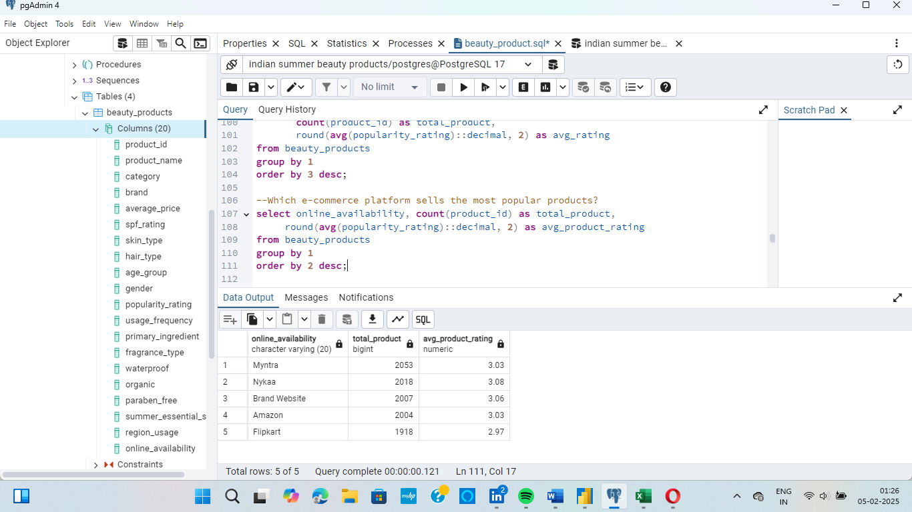**14. Which E-Commerce platform sells the most popular product?**

Insight: Nykaa has the highest-rated products, while Myntra sells the most.

**Technologies Used:**

* SQL – Extracted and transformed raw data for meaningful insights.
* Excel – Cleaned and preprocessed data for accuracy.
* Power BI – Created interactive visualizations for business intelligence.

**Final Thoughts:**

The findings from this analysis provide actionable insights that can help businesses optimize decision-making in the beauty industry. Key takeaways include:

* Identifying pricing trends and premium product categories.
* Highlighting best-selling products across different regions.
* Predicting customer loyalty and seasonal demand patterns.
* Recommending strategies for product expansion and diversification.